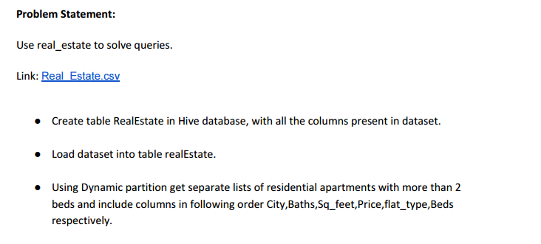

Created a table realestate with all necessary columns and have loaded the datum into the table

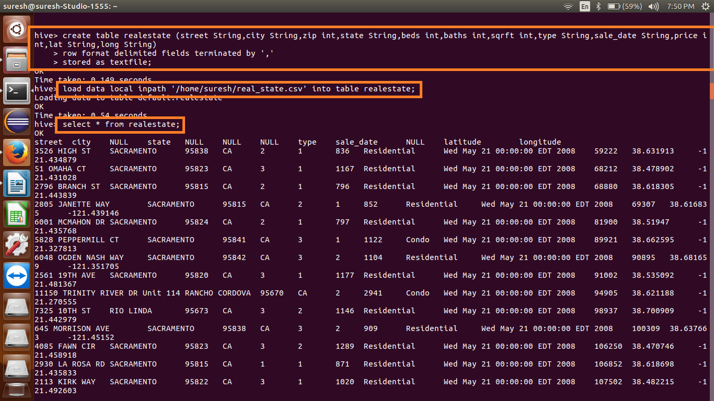

Created a partition table partitioned by type,beds

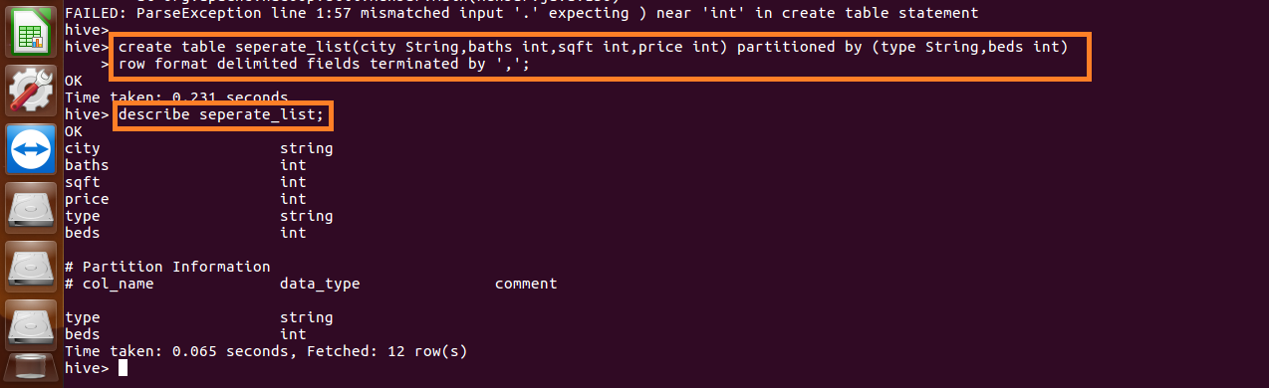

Have inserted the data into the partition table

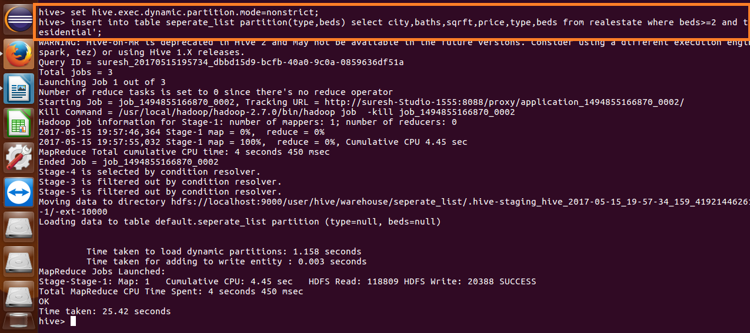

Here we can see the data which are partitioned and stored in HDFS

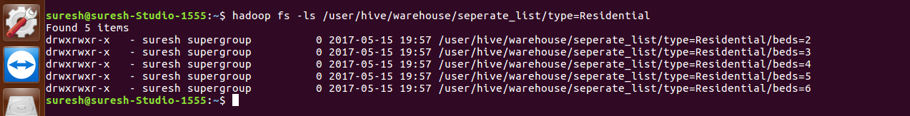

Thus the contents are displayed

